**SVN Case Study**

1. Check your current working directory
2. Before starting the migration, ensure you have the following tools installed:
3. Git
4. Subversion (SVN)
5. Git-svn
6. Create an empty directory for your new Git repository and initialize it:

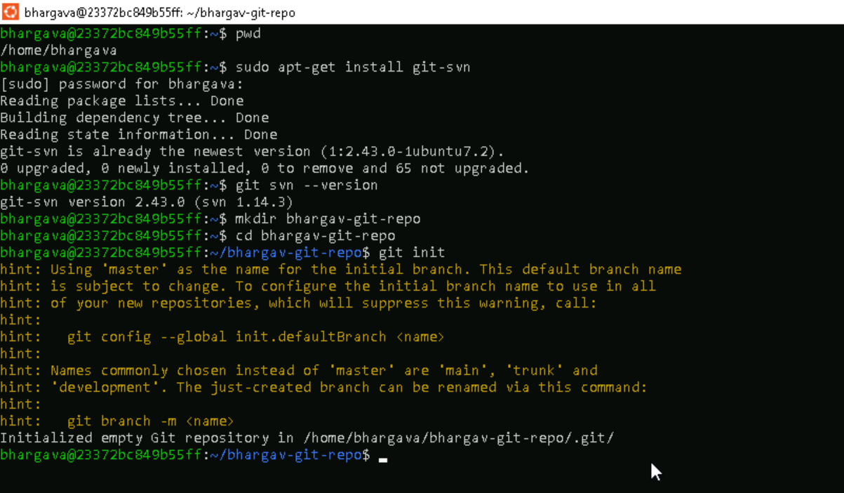

7.Install subversion(SVN) to create a SVN repository

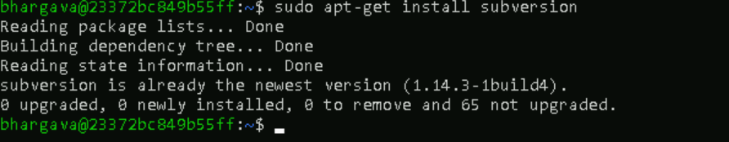

8. Create a SVN repository and repository structure





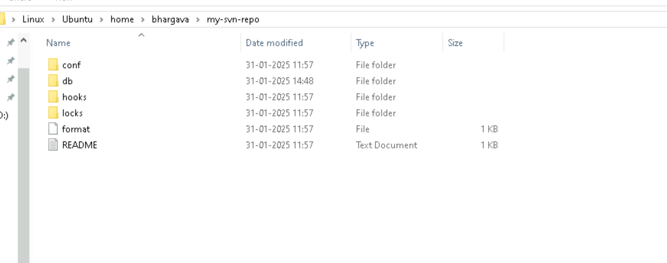

9.Create a test directory called my-working-copy and add files like test-file.txt and file.txt.

10.Add the new files to svn and commit the changes using svn add and svn commit commands.

11.Verify the changes using svn log command

12.Checkout the repository to work locally

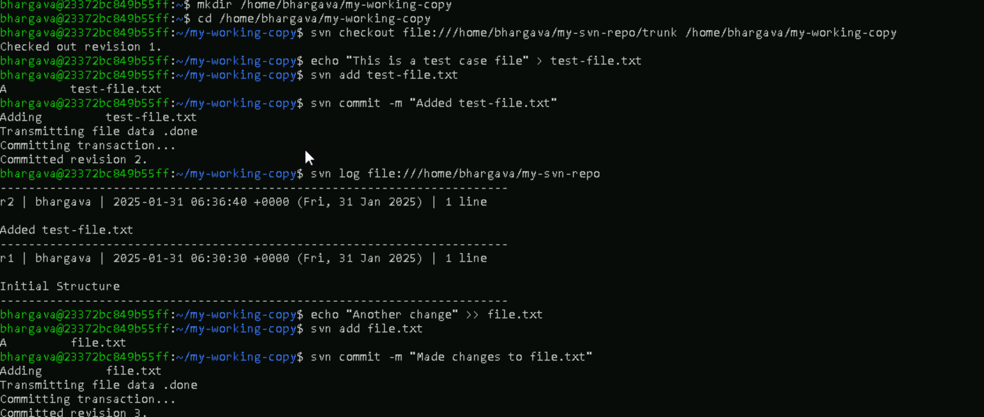

13.Now you will use svn-git to clone the SVN repository into your git repository new-git-repo



